**FACEBOOK**

**Product Dissection for Facebook**

### **Company Overview:**

Facebook is a multinational technology conglomerate headquartered in Menlo Park, California. Founded in 2004 by Mark Zuckerberg and his college roommates, Facebook has grown into one of the world's largest and most influential social media companies. The company's mission is to give people the power to build community and bring the world closer together. Facebook's core platform, initially designed as a social networking site for connecting with friends and family, has evolved into a comprehensive ecosystem of products and services aimed at facilitating communication, content sharing, and online interaction. In addition to the flagship Facebook app, the company owns and operates several other popular platforms, including Instagram, WhatsApp, Messenger, and Oculus VR.

### **Product Dissection and Real-World Problems Solved by Facebook:**

Facebook, as a leading social media platform, has effectively addressed significant real-world challenges through its innovative product offerings. With a multifaceted approach to digital interaction, Facebook empowers users to connect authentically, share their stories, and engage meaningfully with others, thereby bridging the gap between online interactions and genuine relationships. Through features such as status updates, photo and video sharing, and interactive content, Facebook provides a solution to the need for meaningful expression and connection in an increasingly digital world. This core functionality solves the problem of maintaining connections and fostering genuine relationships, allowing users to engage in conversations that transcend geographical boundaries.

Facebook's robust engagement features, including likes, comments, and shares, have transformed how users interact with content, enabling them to express appreciation, share thoughts, and engage in discussions on a wide range of topics. By addressing the challenge of content overload, Facebook curates personalized content feeds based on user preferences and interactions, helping users discover new content, connect with like-minded individuals, and stay informed about topics that matter to them. Furthermore, Facebook's advertising platform provides businesses with targeted advertising solutions, addressing the challenge of reaching and engaging with relevant audiences effectively.

In conclusion, Facebook's product design has successfully tackled real-world problems by creating a platform that fosters authentic connections, encourages self-expression, and facilitates meaningful engagement. Through its diverse features and innovative approach to digital interaction, Facebook addresses the need for genuine relationships, content discovery, and community engagement, shaping the digital landscape and providing practical solutions to the evolving needs of its global user base.

**Case Study: Real-World Problems and Facebook's Innovative Solutions:**

Facebook, as a prominent social media platform, has played a transformative role in reshaping the landscape of digital communication while simultaneously addressing substantial real-world challenges through its innovative features. By recognizing user needs and harnessing technological advancements, Facebook has established itself as a solution-oriented platform that facilitates connections, promotes self-expression, and enriches digital interactions.

#### **Problem 1: Disconnect in Digital Relationships**

**Real-World Challenge:** With the increasing digitization of our lives, the absence of genuine connections in online interactions has emerged as a widespread concern. Users often find it challenging to convey emotions and experiences effectively through text-based communication alone, resulting in a disconnect in digital relationships.

**Facebook's Solution:**

Facebook acknowledges the importance of authentic expression in digital interactions. By providing features such as photo and video sharing, alongside status updates, check-ins, and hashtags, the platform fosters a visually engaging environment where users can share their experiences more vividly. The ability to tell stories through multimedia content helps bridge the gap between online interactions and genuine emotions, facilitating deeper connections among users. Through these initiatives, Facebook effectively addresses the challenge of disconnection, cultivating meaningful relationships and fostering authentic interactions within its community.

#### **Problem 2: Information Overload**

**Real-World Challenge:** The immense volume of content accessible online can inundate users, leading to difficulty in finding relevant and compelling content that matches their interests.

**Facebook's Solution:**

To tackle the issue of information overload, Facebook implements various features aimed at enhancing content discovery and personalization. The platform employs sophisticated algorithms to curate users' News Feeds, prioritizing content based on factors such as user engagement, past interactions, and content relevance. Additionally, Facebook's "Explore" feature propels discovery by suggesting content based on user preferences and interactions, allowing users to explore posts, videos, and stories from accounts they don't follow. Through these initiatives, Facebook strives to streamline content discovery, alleviate information overload, and enrich the user experience.

#### **Problem 3: Finding a Niche for Creativity**

**Real-World Challenge:** Many individuals aspire to express their creativity but struggle to find a platform where they can showcase and monetize their talents effectively.

**Facebook's Solution:**

To address the challenge of finding a niche for creativity, Facebook offers various features and opportunities for individuals to showcase their talents and pursue creative endeavors. Through Facebook Pages and Groups, users can create dedicated spaces to share their creative work, connect with like-minded individuals, and build communities around their passions. Additionally, Facebook's advertising platform provides businesses and creators with tools to reach and engage with their target audiences, offering opportunities for monetization and growth. By fostering a supportive and collaborative environment, Facebook empowers individuals to turn their creative hobbies into viable careers, addressing the real-world challenge of finding a platform for creativity and facilitating personal and professional growth.

#### **Conclusion:**

Facebook's innovative solutions have effectively addressed real-world challenges, particularly in the realm of digital communication and social interaction. By recognizing the importance of authentic connections and meaningful relationships, Facebook has implemented various features and initiatives to bridge the gap between online interactions and genuine human connections Through its core features such as status updates, photo and video sharing, and interactive content, Facebook provides users with a platform to express themselves, share their stories, and engage with others authentically. This has helped alleviate the sense of disconnect and isolation that can arise in the digital age, fostering connections that transcend geographical boundaries and enriching the lives of users worldwide.

### **Top Features of facebook:**

**User Profiles:** Facebook allows users to create personal profiles, providing insights into their lives through features such as usernames, full names, bios, and profile pictures. This creates a personalized online presence that reflects each user's identity.

**Posts:** A fundamental feature of Facebook is the ability to share various types of content, including text, photos, videos, links, and events. Users can craft posts to express their thoughts, share updates, or engage with their network.

**Interactions:** Engagement is key on Facebook, with users able to react to posts using options such as Like, Love, Haha, Wow, Sad, and Angry. Additionally, users can comment on posts to share their thoughts and opinions, fostering meaningful interactions.

**Friends and Following:** Facebook facilitates connections through the Friends system, allowing users to connect with friends, family, and acquaintances. Users can send friend requests, accept requests from others, and unfollow or block users as needed. Additionally, users can follow public figures, organizations, and brands to receive updates from their Pages.

**Explore:** Facebook's Explore feature allows users to discover new content and connect with like-minded individuals. Users can explore posts, articles, videos, and events based on their interests and interactions, fostering a diverse online experience.

**Groups:** Facebook Groups provide a space for users with shared interests, hobbies, or affiliations to come together and engage in discussions, share content, and organize events. Groups can be public, private, or secret, depending on the privacy settings chosen by the group admin.

**Events:** Facebook Events allow users to create, discover, and RSVP to events happening in their local area or online. Users can invite friends, share event details, and see who else is attending, facilitating social gatherings and community engagement.

**Marketplace:** Facebook Marketplace enables users to buy and sell items locally or nationally. Users can browse listings, search for specific items, and communicate with sellers or buyers directly through the platform.

**Watch:** Facebook Watch is a platform for discovering and watching original video content, including shows, series, and live events. Users can explore a variety of content categories, follow their favorite creators, and engage with fellow viewers through comments and reactions.

**Gaming:** Facebook Gaming provides a platform for gamers to discover, play, and connect with others. Users can watch live streams, join gaming communities, and play a variety of instant games directly on the platform.

**Advertising:** Facebook's advertising platform allows businesses to create targeted ad campaigns to reach specific audiences based on demographics, interests, and behaviors. This enables businesses to promote their products or services effectively and reach potential customers across the platform.

### **Schema Description:**

The schema for Facebook encompasses various entities that represent different components of the platform. These entities include Users, Posts, Comments, Reactions, Friends, Groups, Events, Pages, and more. Each entity possesses specific attributes that delineate its characteristics and relationships with other entities.

**User Entity:**

Users are fundamental to Facebook's platform. The user entity comprises information about each user:

**UserID (Primary Key):** A unique identifier assigned to each user.

**Username:** The chosen username associated with the user's account.

**Email:** The email address linked to the user's account for communication purposes.

**Full_Name:** The user's full name as displayed on their profile.

**Bio:** A concise description that users can utilize to express themselves.

**Registration_Date:** The date when the user joined Facebook.

**Post Entity:**

Posts represent the diverse content shared on the platform:

**PostID (Primary Key):** A unique identifier assigned to each post.

**UserID (Foreign Key referencing User Entity):** Identifies the user who authored the post.

**Content:** The textual or multimedia content shared in the post.

**Attachment_URL:** The URL linking to any attached media, such as images or videos.

**Location:** The tagged location associated with the post, if applicable.

**Post_Date:** The timestamp indicating when the post was created.

**Comment Entity:**

Comments facilitate user interaction and discussion on the platform:

**CommentID (Primary Key):** A unique identifier for each comment.

**PostID (Foreign Key referencing Post Entity):** Identifies the post to which the comment is attached.

**UserID (Foreign Key referencing User Entity):** Indicates the user who authored the comment.

**Content:** The text content of the comment.

**Comment_Date:** The timestamp indicating when the comment was posted.

Like Entity:

**Like Entity:**

Likes represent user engagement with posts and comments:

**LikeID (Primary Key):** A unique identifier for each like.

**UserID (Foreign Key referencing User Entity):** Identifies the user who liked the post or comment.

**PostID (Foreign Key referencing Post Entity):** Indicates the post being liked, if applicable.

**CommentID (Foreign Key referencing Comment Entity):** Indicates the comment being liked, if applicable.

**Like_Date:** The date and time when the like was registered.

**Follower Entity:**

Followers establish connections between users:

**FollowerID (Primary Key):** A unique identifier for each follower relationship.

**FollowingUserID (Foreign Key referencing User Entity):** Identifies the user who is being followed.

**FollowerUserID (Foreign Key referencing User Entity):** Identifies the user who is following.

**Follow_Date:** The date when the following relationship was initiated.

**Hashtag Entity:**

Hashtags categorize and group content:

**HashtagID (Primary Key):** A unique identifier for each hashtag.

**Tag:** The actual text of the hashtag.

**PostHashtag Entity:**

Associates posts with hashtags:

**PostHashtagID (Primary Key):** A unique identifier for each association.

**PostID (Foreign Key referencing Post Entity):** Identifies the post associated with the hashtag.

**HashtagID (Foreign Key referencing Hashtag Entity):** Identifies the hashtag associated with the post.

**Relationships are:**

**Users create Posts –** Each user can create multiple posts.

**Users write Comments on Posts –** Users can write comments on multiple posts, and each post can have multiple comments.

**Users react with Likes on Posts –** Users can react with likes on multiple posts, and each post can have multiple likes.

**Users follow other Users –** Users can follow multiple users, and each user can be followed by multiple users.

**Posts contain Hashtags –** Posts can contain multiple hashtags, and each hashtag can be associated with multiple posts.

**ER Diagram:**

Constructing an ER (Entity-Relationship) diagram for Facebook involves identifying the main entities and their relationships within the platform. 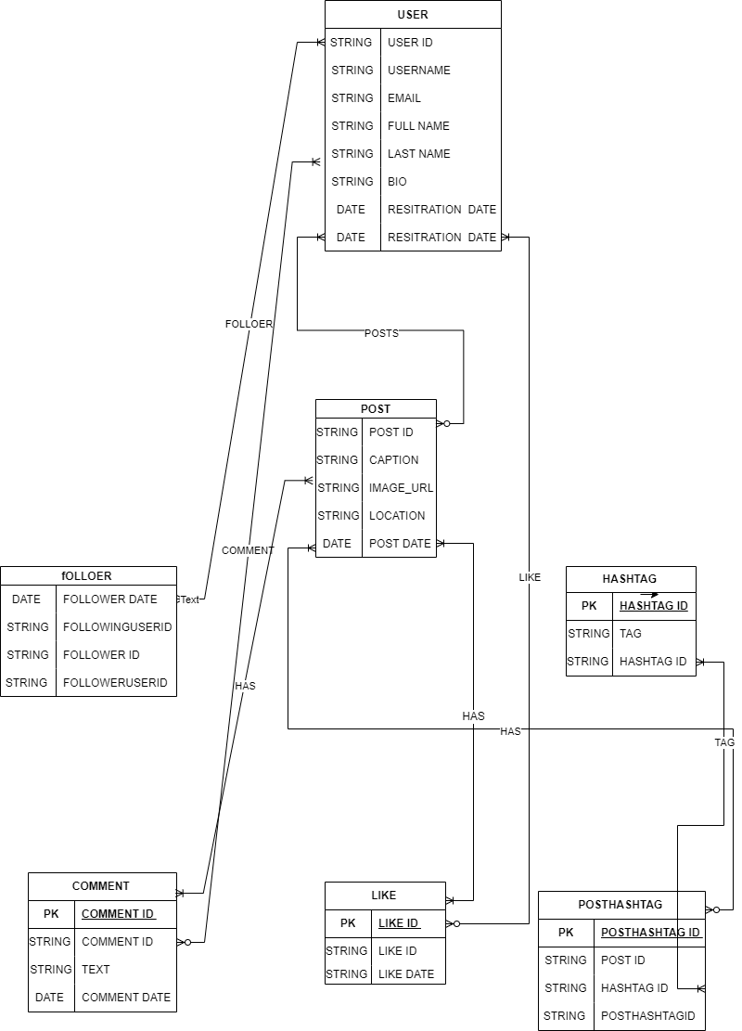

**Explanation:**

The ER diagram illustrates the main entities in Facebook's data model and their relationships. Here's a breakdown:

**User:** Represents the users of the platform. Each user has a unique user_id and can have attributes such as username, email, password, bio, profile picture, and join date.

**Post:** Represents the posts made by users. Each post has a unique post_id and is associated with the user who created it. Posts contain content and are time stamped with a post date.

**Comment:** Represents the comments made on posts. Each comment has a unique comment_id and is associated with both the post it belongs to and the user who wrote it. Comments contain text and are time stamped with a comment date.

**Like:** Represents the likes given to posts by users. Each like has a unique like_id and is associated with both the post it belongs to and the user who liked it. Likes are time stamped with a like date.

**Friend:** Represents the friendships between users. Each friendship has a unique

friendship_id and is established between two users (user1_id and user2_id). The friendship status attribute indicates whether the friendship is pending, accepted, or declined.

This ER diagram provides a clear visualization of the relationships and attributes within Facebook's data model, depicting how users, posts, comments, likes, and friendships are interconnected within the platform.

**Conclusion:**

The ER diagram effectively captures the essence of Facebook's data model, highlighting the user-centric nature of the platform, the dynamics of content sharing and interaction, the interconnectedness of relationships, and the importance of data integrity and security.